Record year for TV drama while feature numbers slump, says Screen Australia
[Thu 03/11/2016 3:01 PM]
By Jackie Keast
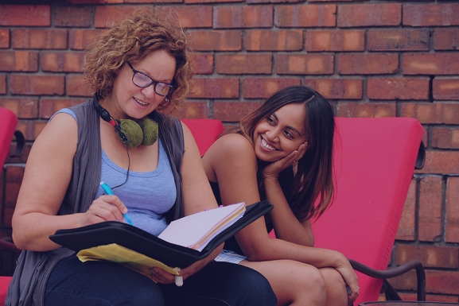
Leah Purcell and Jessica Mauboy on the set of 'The Secret Daughter'.

Australian TV drama expenditure has reached a record high of $376 million, according to the 2015-16 Screen Australia Drama Report.
The report stated that this increase – up 25 per cent on the previous financial year – has been driven by mini-series production such as Barracuda, Deep Water and The Secret Daughter.
The annual report from Screen Australia tracks feature films and TV dramas shot or post produced in Australia during the financial year, including SVOD titles. It monitors for hours, spend and sources of finance and is used to assess the health of the industry.
Overall, $843 million was spent across 118 productions (Film and TV) in Australia this year; $570 million from Australian projects and $273 million from foreign productions. These figures are down just 1 per cent from last’s years record $853 million.
In terms of expenditure by location, the figures are stacked heavily towards the east coast – with 55 per cent of that total spent in NSW, 26 per cent in Victoria and 12 per cent in Queensland.
Bumper TV year
As well as significantly bolstered expenditure, it was also a record year in terms of the number of television titles produced – 58 – and total budgets, which added up to $416 million. Total hours also increased to 561, up 43 from the previous financial year.
The news should be welcome to the industry, given last year’s TV drama stats were of great concern – with Screen Producers Australia CEO Matthew Deaner calling for urgent action at the 2015 Screen Forever conference.
The push towards mini and shorter form series was clear, with the majority of this year’s titles less than 10 hours in total. With the exception of both Home and Away and Neighbours, long-form series of 20 episodes or more were absent from the slate.
Children’s drama had a slightly increased spend of $66 million. However the number of hours declined below the five year average, due to a fall off in co-productions. There was only one co-pro this year, Beat Bugs, between Australia and Canada.
Subscription TV had its strongest production year on record thanks to the likes of new shows Secret City and Pacific Heat, and returning series such as Wentworth and Top of the Lake. The report also noted that online continues to grow, thanks to shows such as the DAFUQ?, The Katering Show and Wolf Creek.
Broadcasters remain the leading financiers of TV, with the largest proportion of funding coming from the commercial free-to-air networks. That said, the ABC provided the largest contribution of any single broadcaster, backing 21 titles. The ABC also accounted for the largest share of total budgets of a single broadcaster since 2011-12.
Government funding for TV has increased slightly, with 91 per cent of titles receiving assistance. Fifty-three (53) per cent received Screen Australia funding, compared to an average of 40 per cent over the four years prior. The Producer Offset contributed $46 million, up $8 million from last year.
Screen Australia CEO Graeme Mason said TV’s record expenditure was the stand-out feature of this year’s report.
“I’m delighted to see every single network had multiple dramas in production – an unprecedented 58 in total – responding to the Australian audience’s appetite to watch their own stories on screen,” he said.
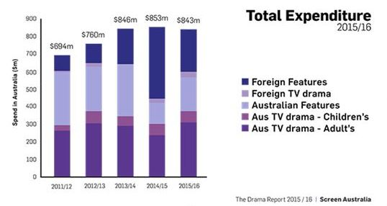
Breakdown of spend per category.
Australian feature spend below average
Twenty-nine Aussie features were produced over the financial year; the lowest number of titles in the last five years. Total expenditure was $194 million, below the average $235 million seen over the last five years.
However, figures are still up $73 million from the last financial year – bolstered by Mel Gibson’s Hacksaw Ridge and Australia-China co-pro Nest.
“It’s encouraging to see feature film production grow [in terms of spend]. We do tend to see more ebb and flow in this area depending on the number of titles and their individual budgets,” said Mason.
According to the data, a vast majority – 76 per cent – of the year’s Australian features were made for less than $6 million, with most costing between $1-$3 million.
Foreign investment made up the highest proportion of Australian feature financing, making up 33 per cent or $69 million.
Government funding significantly increased to $32 million or 16 per cent of financing. This included $18 million from Screen Australia and $14 million from the state agencies – 81 per cent of which came from Screenwest, Screen NSW and Film Victoria. The remainder came from organisations such as the Australia Children’s Television Foundation and festivals such as MIFF.
The Producer Offset accounted for $65 million – 31 per cent of total financing, while industry contributions increased to $30 million or 14 per cent. Private investment was down on last year, making up only 5 per cent of total financing.
Foreign production drops after record high
As was expected, foreign production dropped 37 per cent following last year’s record breaking $431 million; a year Screen Australia called “atypical”.
However, this year’s $273 million spend still remains above the five year average, with an increased number of foreign titles – 31 – cushioning the anticipated fall.
Seven features and two TV dramas shot in Australia over the year. Fifteen foreign features and seven TV drama projects undertook post, digital and visual effects.
In particular, Mason said Australia is making a name for itself in the PDV [Post, Digital and Visual Effects] space, with Australians contributing to X-Men: Apocalypse, Ghostbusters and Game of Thrones.
Industry says ‘headwinds remain’
Screen Producers Australia CEO Matthew Deaner welcomed the report, stating that it showed modest but mixed improvement.
“This Drama Report shows there are green shoots for the industry after a difficult year last year in 2014/15. The record level of television drama spend and titles in 2015/16 is timely and welcome,” he said.
However, Deaner noted that “serious headwinds remain” and that cuts to the ABC and Screen Australia are being keenly felt.
“These reductions are yet to be balanced by long-fought-for increases to the offset for television production,” he said.
While SPA saw shorter-run series as contributing to diversity of programming and opportunities for production companies, it noted that minis increase the cost per hour – putting pressure on commercial broadcasters to meet quotas.
Deaner said that the feature film space in Australia “has been inert for a few years now.”
“This is a concern and Screen Producers Australia is working hard with industry colleagues domestically and internationally to attract greater investment in local productions,” he said.
Free TV Australia CEO Brett Savill said the report showed commercial free-to-air’s “unrivalled” commitment to investment in Australian TV drama.
“Despite the difficult market conditions that the industry faces, our commitment to producing Australian content has remained steadfast – spend on Australian content accounts for a massive 78 per cent of Free TV broadcasters’ total expenditure,” Mr Savill said.
However, Savill said the economic and advertising environment remains challenging and threatens the industry’s ability to continue to invest in Australian content.
“Australian broadcasters pay the highest licence fees in the world – more than 115 times the fees paid in the US. This punitive regulatory framework is not sustainable and must be urgently addressed,” he said.
“No other platform offers our range of quality local programming, to more than 13 million Australians every day, for free. It underlines our social and cultural identity. The ability to maintain our investment is critical.”
Read Screen Australia's 2015-16 Drama Report here.
[Thu 03/11/2016 3:01 PM]

